REPORT
Introduction:
Recently I finished the “Analyzing and Visualizing Data in Looker” course on Google Cloud Skills Boost where I developed the basic understanding of Looker as a data analysis and visualization tool through practical tasks. I gained confidence in using Looker to generate reports that I may not require extensive coding skills to create in this course and understanding how to work with Looker platform tools as well as creating meaningful visuals for real-life purposes.
Key Learnings and Comparison to Looker Studio and Python/R:
This course focused on Looker’s interface and content organization, as well as the structuring of its content. At first, I thought the platform was quite confusing in terms of interface, but it soon became clear how to easily assign panels for visualizing data. The three primary tools of implementation basic to Looker are Dimensions, Measures, and Filters, which are the basic building blocks for focus visualization. Due to hands-on labs, I came to learn how these tools work in real life, for example, in categorizing data by dimensions calculations with measures. Constructing the interactive dashboards as well as organizing data on boards helped realize how Looker encourages data sharing and teamwork.
In the final sections of the course material, I studied such a tool as custom metrics when I was able to carry out quite detailed analysis directly in Looker with the help of such tools as pivoting. This was just timesaving on external data manipulation. I also like the features of sharing as report scheduling and permissions management for better info spreading. Looking at Looker as the platform for Looker Studio and coding in Python or R then Looker Studio is an instrument for the prompter and easier immediate reports. The Looker/Data Studio Lab and Enterprise Looker course showed me that Looker Studio is great for quick, simple dashboards, while Enterprise Looker is much stronger for deep, complex analytics. Each tool has unique strengths based on project needs. For larger projects, Looker does quite a good job at dealing with complex analysis. However, Python and R extend a better opportunity to customize and hence secure better for numerical analysis. While Looker has the great advantage with direct reporting being much faster than using the coding language, the coding languages are preferred for highly detailed analysis of data.
Conclusion:
This course helped me to develop my Looker skills that improved data visualization, personal reporting, and sharing knowledge. I decided based on the data need whether it is easier to use Looker, Looker Studio, Python, or R to meet that need. If you need to make fast and effective reports, Looker is the right choice; if you need faster and even simpler tools, it is better to use Looker Studio; and if you need detailed and individually tailored analyses, Python or R are the most suitable. This gives me a wide range of tools that I can use to best fit the projects that I am addressing according to plan.

Appendix
LABS:

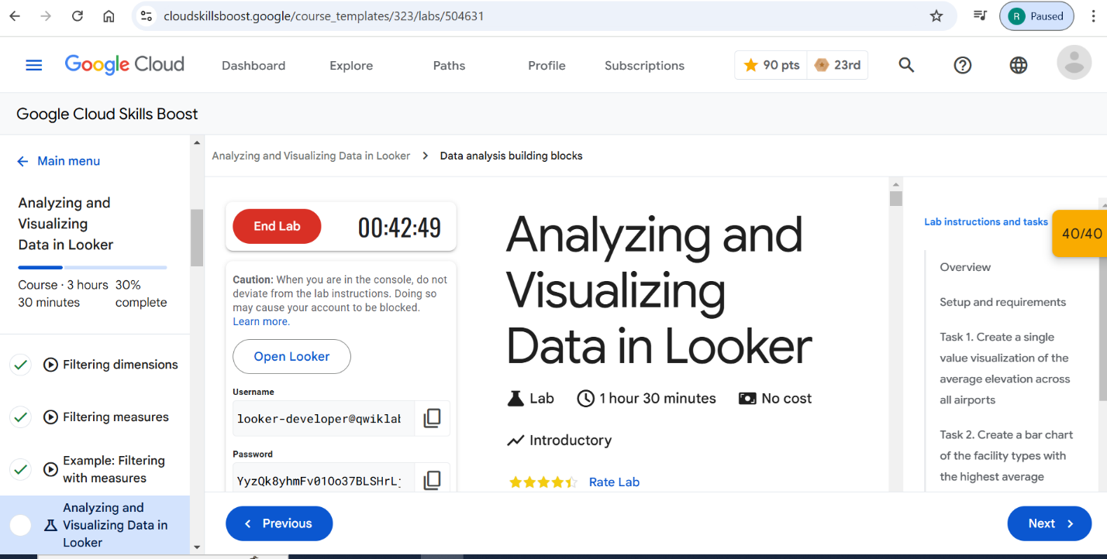

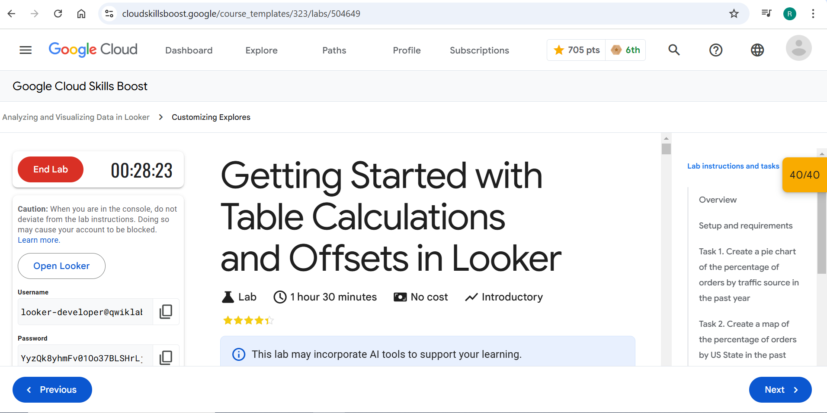

QUIZES:

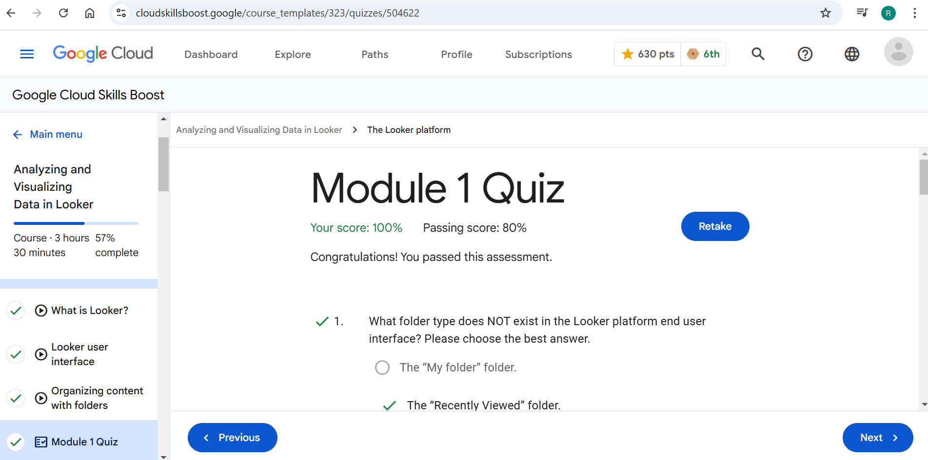

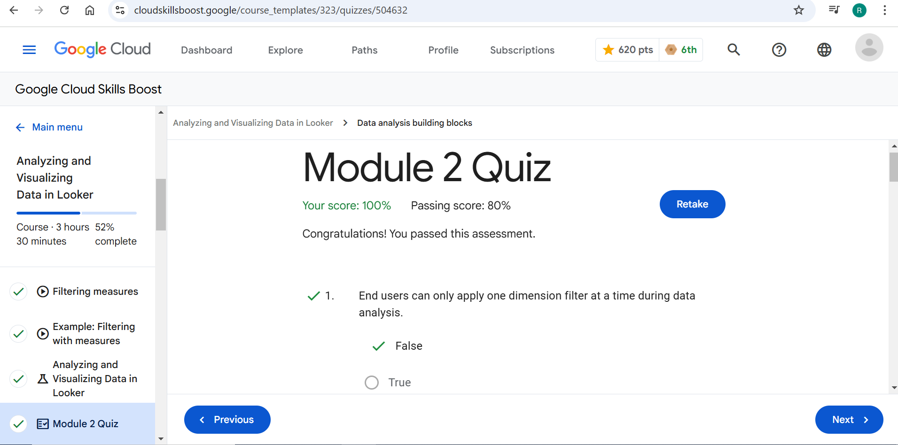

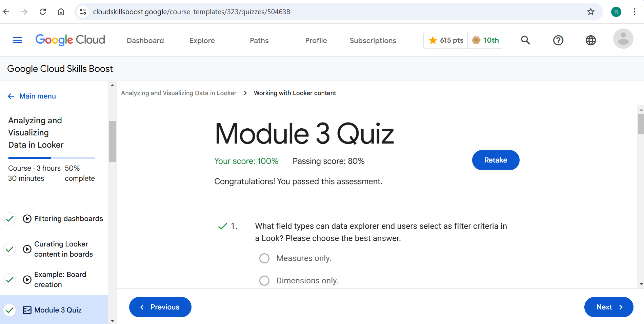

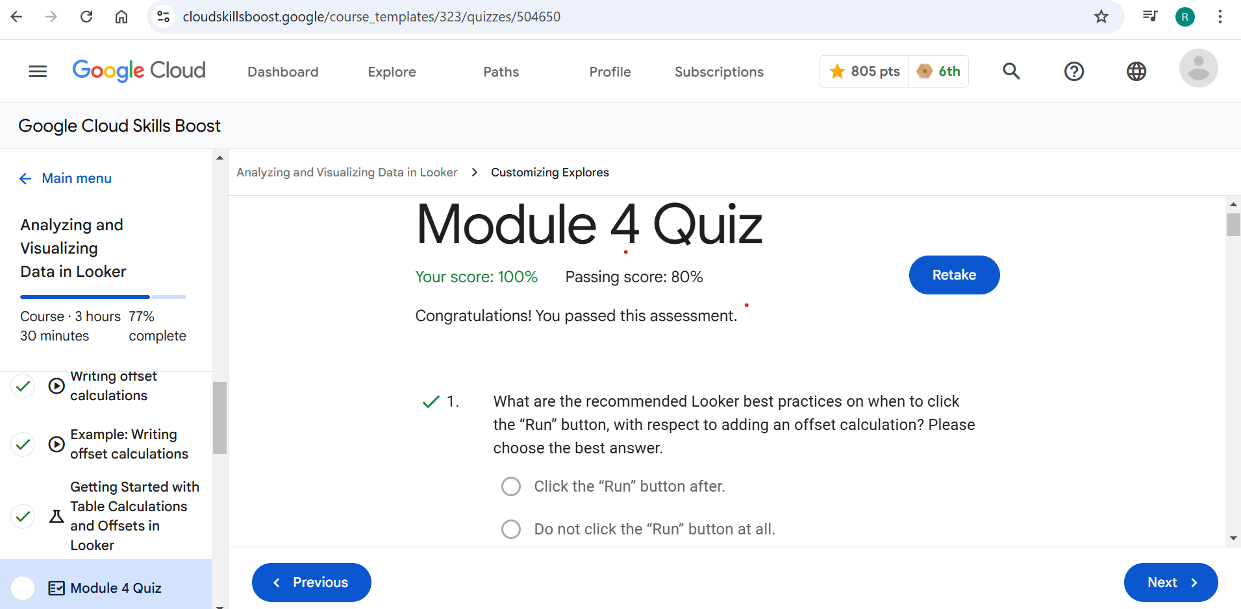

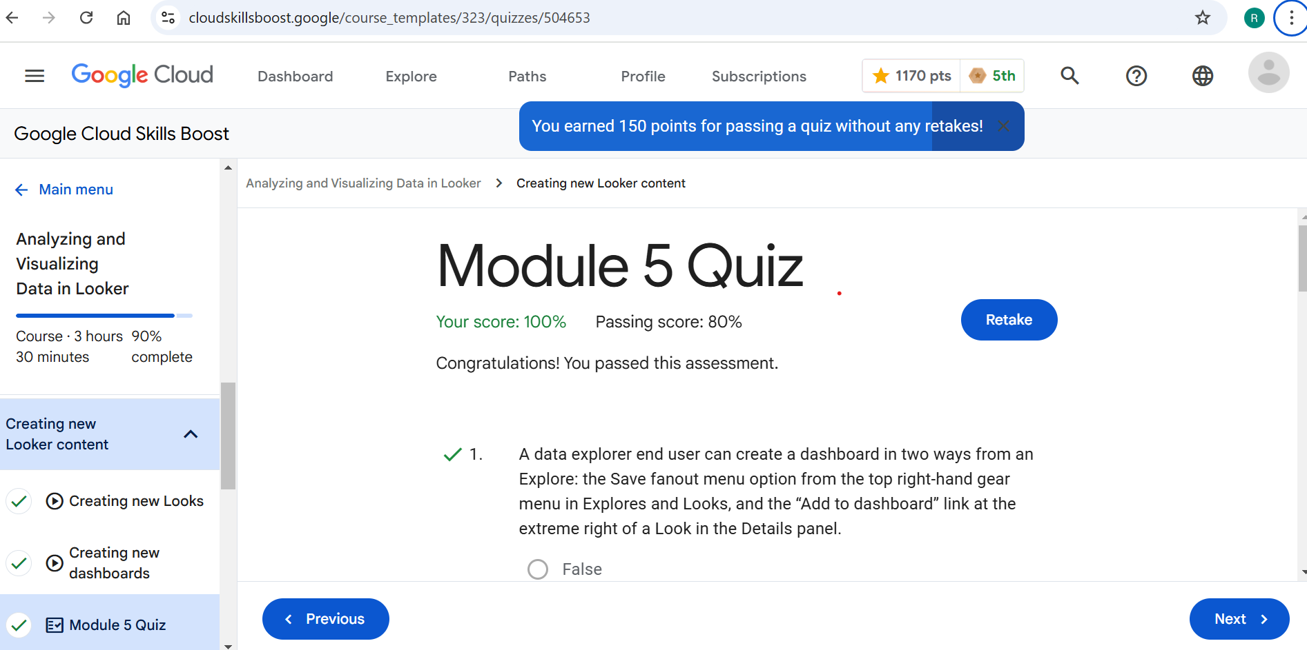

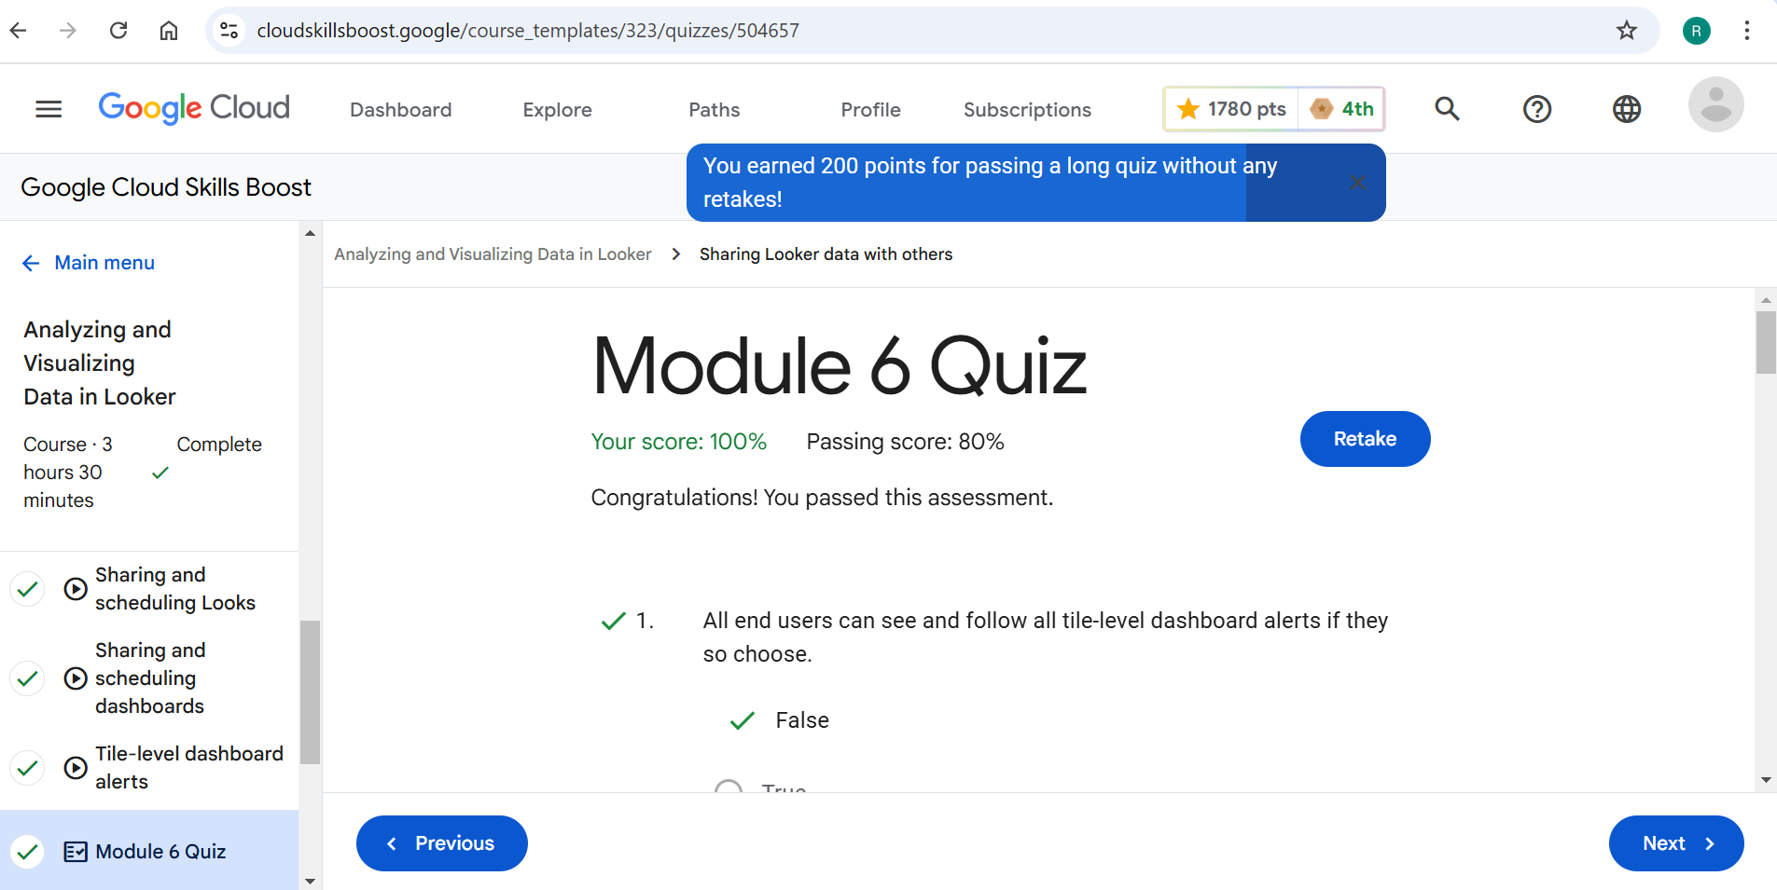

COURSE BADGE:
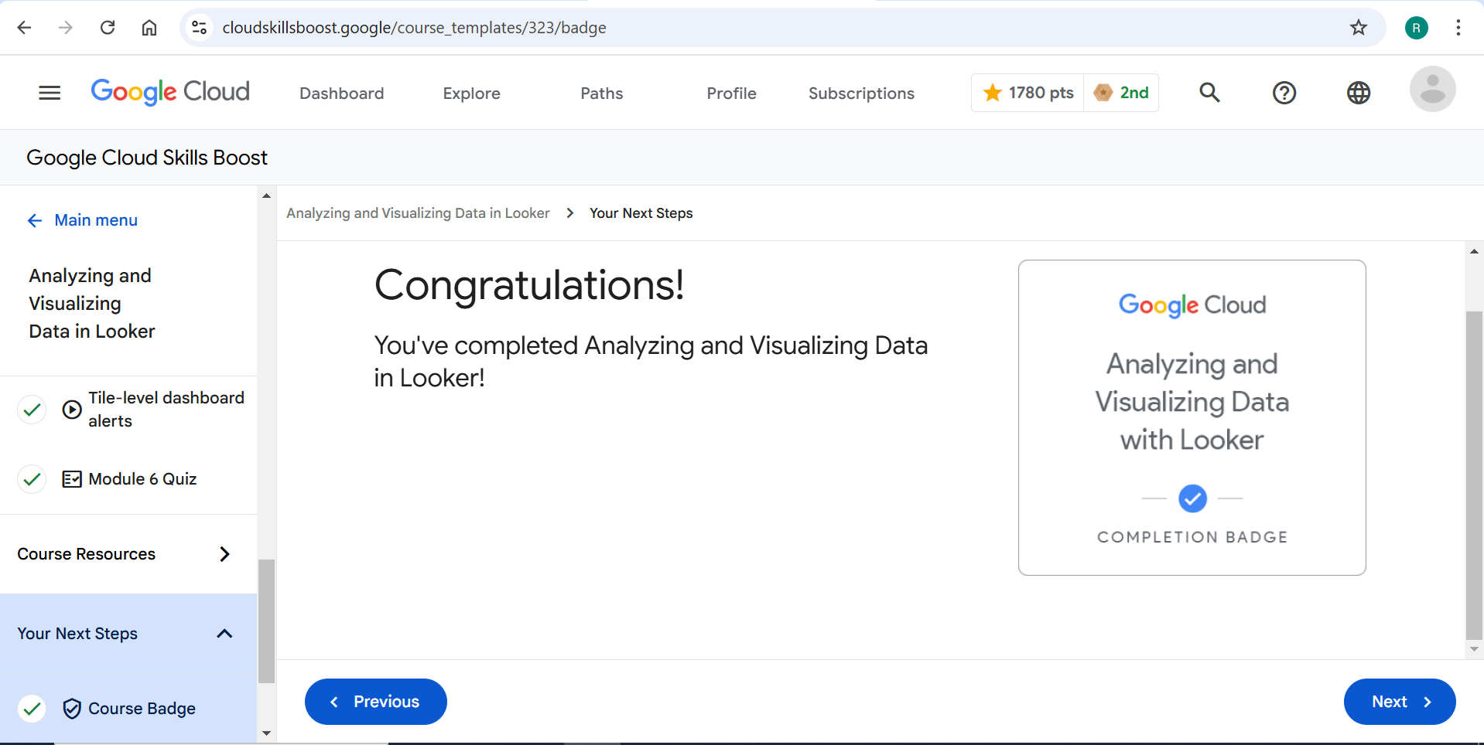
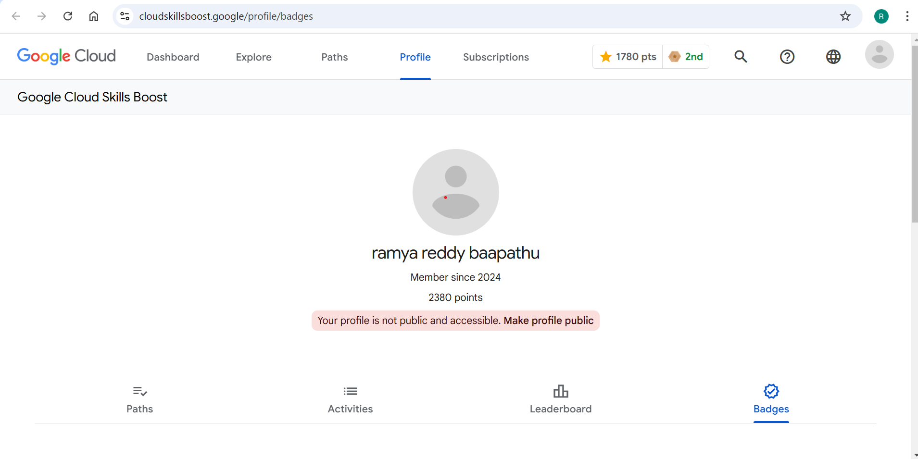

References:
For cloud skills boost:
https://www.cloudskillsboost.google/course_templates/323
for badge
https://www.cloudskillsboost.google/profile/badges

